PD_TC _05 - OrangeHRM_Personal Details _Enter the First Name with alpha-numeric characters

Launch the URL

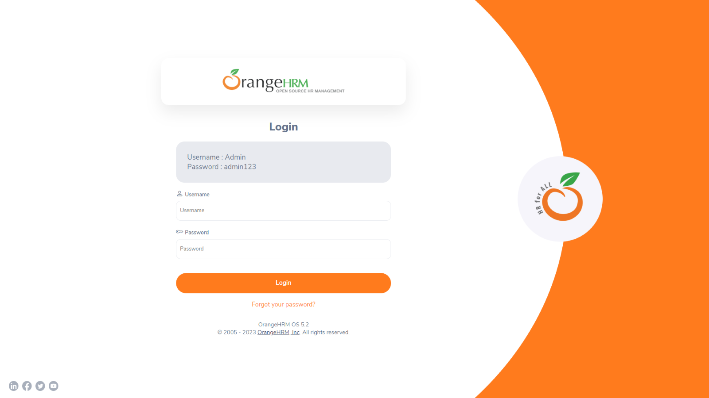

Login to the application with Valid credentials

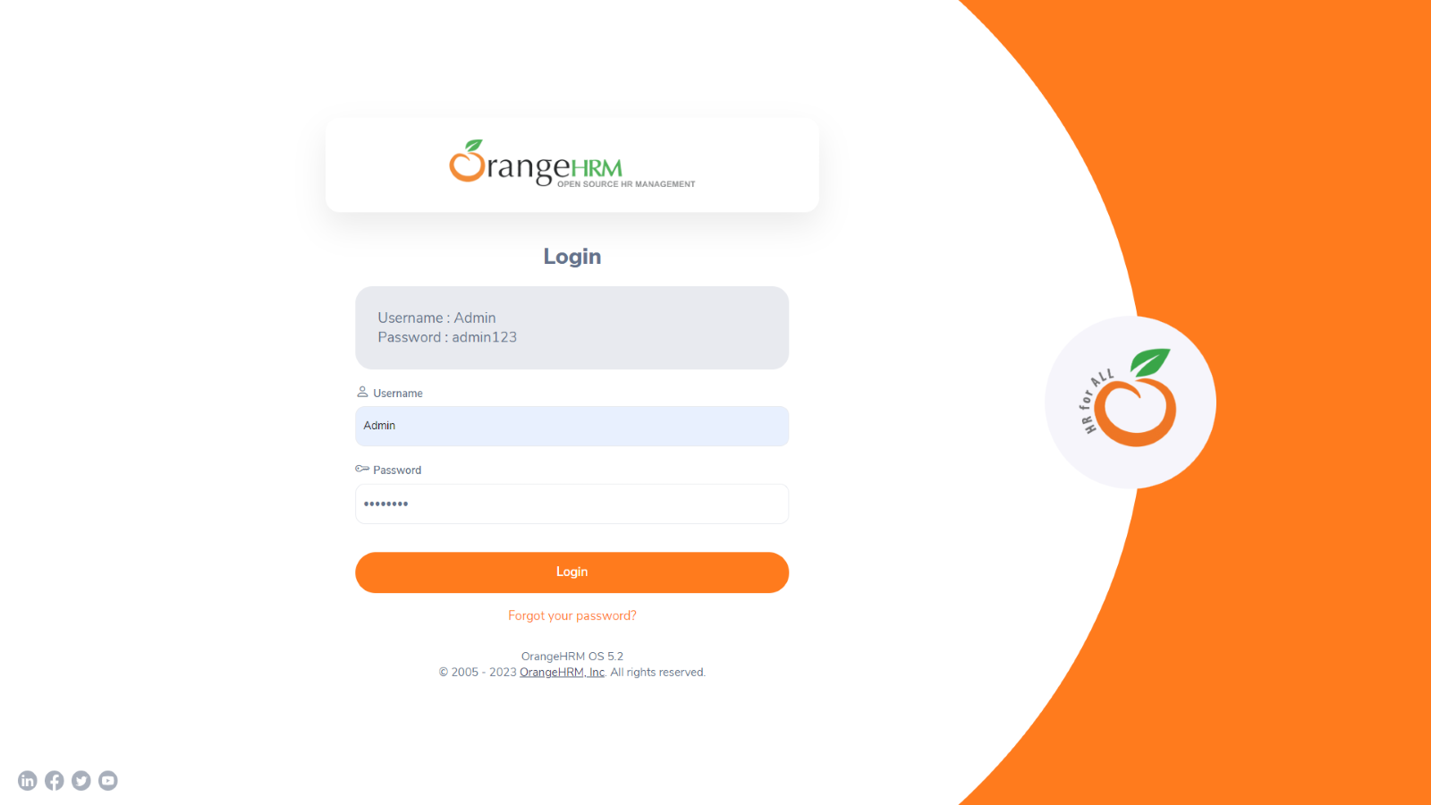

Logged successfully & navigated to personal details tab

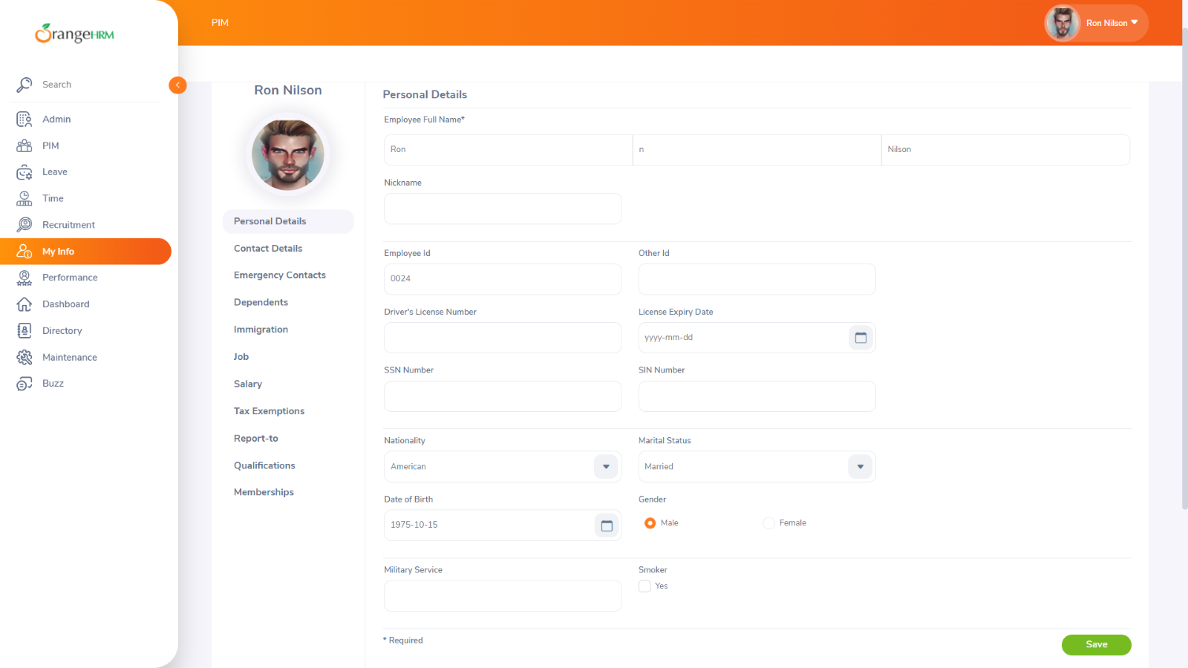

Enter the First Name with alpha-numeric characters



